**ENGINEERING METHOD AND ANALYSIS OF REQUIREMENTS CED OF2.**

Development:

1. **Engineering method.**

**Problematic context.**

An internet connection service company in rural areas, has faced significant challenges in one of the towns to which it provides its service. In recent times, numerous complaints have arisen due to frequent network outages in that particular area. This situation has generated a negative impact on users and has affected their ability to perform online activities smoothly.

The problem is intensified because the company only has a network antenna to provide a signal to the entire town. The lack of additional infrastructure limits the company's ability to offer a reliable and stable service in this particular area. As a result, local residents and businesses suffer, experiencing frequent interruptions to their internet connection, affecting their productivity, communication, and access to online services.

Expansion of the network infrastructure: The installation of additional antennas that provide greater coverage in the affected locality should be established, so as to reduce the areas with poor or non-existent signal.

Improved network stability: The solution must guarantee a more stable and reliable internet connection, minimizing network drops and ensuring optimal performance at all times.

Resource optimization: It is essential to make efficient use of available resources, considering the limitations of rural location and associated costs. The solution must seek a balance between service quality and profitability.

Maintenance and monitoring: The implementation of a network maintenance and monitoring system is required, which allows for the rapid identification and resolution of any incident or failure in the Internet connection.

Customer service: The solution must consider customer satisfaction as a key factor. Effective communication with users is expected to be established, providing timely and efficient technical support, and adequately managing complaints and inquiries related to the Internet service.

**Solution development.**

**Step 1. Identification of the Problem.**

**Problem:**

*Identification of needs and symptoms.*

**Needs:**

* Expanded coverage: The company needs to install additional antennas to improve network coverage in the affected location and reduce areas with poor or no signal.
* Network stability: A solution is required that guarantees a more stable and reliable internet connection, minimizing network drops and ensuring optimal performance at all times.
* Resource optimization: It is necessary to make efficient use of available resources, considering the limitations of rural location and associated costs, to find a balance between service quality and profitability.
* Maintenance and monitoring: It is necessary to implement a network maintenance and monitoring system that allows to quickly identify and solve any incident or failure in the Internet connection.
* Customer Service: Customer satisfaction is a key need. It is necessary to establish effective communication with users, provide timely and efficient technical support, and adequately manage complaints and inquiries related to the Internet service.

**Symptoms:**

* Frequent network outages: Users experience frequent interruptions in their Internet connection, which affects their productivity, communication, and access to online services.
* Deficient or non-existent signal: There are areas in the affected locality where the internet signal is weak or non-existent, which limits the ability of users to use online services fluently.
* Negative impact on users and local businesses: Interruptions in the Internet connection generate a negative impact on the productivity and communication of users and affect the ability of local businesses to conduct their activities online.
* Lack of additional infrastructure: The company only has one network antenna to provide a signal to the entire town, which limits its ability to offer a reliable and stable service in the affected area.
* Complaints and inquiries from users: The company has received numerous complaints and inquiries from users due to connection problems and the lack of stability in the Internet service in the affected location.

*Definition of the problem.*

The objective problem is the lack of coverage and stability in the Internet connection service in a specific rural location. This is due to the limited network infrastructure, with only one antenna available, which is insufficient to provide a reliable and stable signal to all users in the area. As a result, there are frequent network outages, areas with poor or non-existent signal, negatively impacting the productivity, communication, and access to online services of users and local companies. In addition, user complaints and queries show dissatisfaction with the current service.

**Step 2. Information Collection.**

**Power Line Communication (PLC):** It is a technology that allows the transmission of data through the existing electrical network. Instead of using dedicated data cables, the PLC uses existing electrical wiring to transmit communication signals. The PLC can be used both in domestic environments and in industrial applications. In the domestic sphere, it is mainly used to transmit data through the electrical network for the interconnection of devices in the home, such as computers, smart TVs, security systems, etc. This avoids the need to install additional network cables and allows for more convenient connectivity.

**Low Earth Orbit (LEO):** They are satellites that are at a relatively low altitude above Earth, generally between 160 and 2,000 kilometers. Unlike satellites in higher orbits, LEOs are closer to the Earth's surface and complete one orbit around the Earth in a relatively brief period, typically between 90 minutes and 2 hours. LEO satellites are used in a variety of applications, including telecommunications, Earth observation, navigation, and scientific data collection. Some of the more well-known LEO satellite-based systems include the Global Positioning System (GPS), which provides navigation and positioning services, and constellations of satellites to provide global Internet connectivity.

**Sources:**

<https://es.wikipedia.org/wiki/Power_Line_Communications>

<https://www.internetsociety.org/es/blog/2022/02/que-es-un-sistema-de-satelite-leo-y-como-puede-ayudar-a-que-internet-sea-mas-grande/>

**Step 3. Search for Creative Solutions.**

These viable solutions were raised as a result of brainstorming among the members of the group and research on network and telecommunications infrastructures currently in the world.

* **Implementation of long-range wireless technology:** Instead of relying solely on a network antenna, the option of using long-range wireless technologies such as mesh networks or point-to-point links could be explored. These solutions would make it possible to establish more robust and stable connections in remote areas, efficiently extending coverage without the need to install multiple antennas.
* **Use of broadband satellites:** Contracting internet services through broadband satellites could be considered. These satellites provide global coverage and could be used to connect remote rural areas. Although it may require a significant upfront investment, this solution would overcome geographic limitations and offer a more stable and reliable service to users.
* **Collaboration with local and community suppliers:** The internet service company could establish alliances with local service providers or with the community itself. This could involve installing antennas on existing buildings or infrastructure, such as schools, churches, or community centers, to extend coverage in a decentralized manner. In addition, collaboration with the community can help identify creative solutions tailored to the specific needs of the locality, drawing on local resources and knowledge.
* **Use of mesh network technology:** Implement a mesh network consisting of multiple transmission and reception nodes strategically distributed in the locality. These nodes will communicate with each other and share the load of the Internet connection, allowing a broader and more stable coverage. This solution would also provide redundancy in case of failure on a specific node.
* **Use of power line technology for data transmission:** Take advantage of the existing electrical infrastructure in the town to establish a data transmission network through power lines. This technology, known as Power Line Communication (PLC), would make it possible to connect to the Internet through electrical cables, avoiding the need for new antennas or additional infrastructure.
* **Use of low-orbit satellite communication technology:** Examine the possibility of using constellations of Low Earth Orbit (LEO) satellites to provide connectivity to the locality. These satellites offer lower latency and higher bandwidth capacity compared to traditional satellites, which would result in a faster and more reliable connection for rural users.

**Step 4. Transition from Ideas to Preliminary Designs.**

* After a deliberate dialogue between the members of the team and the analysis of the special needs of the problem, the following preliminary designs were discarded:

***Alternative 2: Use of wide band satellites***

* In terms of connection quality, this system is considered one of the most advanced solutions available today. However, it is important to note that it is also the most expensive alternative. The expenses associated with the acquisition and maintenance of this satellite could result in financial losses for the company.

In addition, it is important to highlight that these types of systems are subject to possible failures due to signal obstruction in areas with rainy climates or intense winds. These weather conditions can affect the quality of the connection, which would generate interruptions in the service.

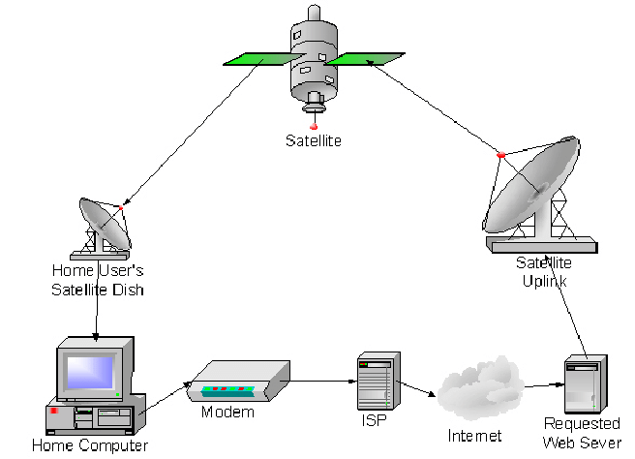

Imagen 1: Example of satellite broadband connection  
<https://www.researchgate.net/figure/Satellite-Broadband-Network-Architecture_fig1_228556895>

***Alternative 5: Use of power line technology for data transmission***

* Although the PLC offers advantages in terms of ease of installation and scope of coverage, it also has some limitations. For example, the data transmission speed may be slower compared to other communication technologies, such as Wi-Fi or Ethernet cable. Signal quality can be affected by the presence of electrical noise and the distance between connected devices. In addition, it is difficult for this technology to be of the size for an infrastructure of this size.

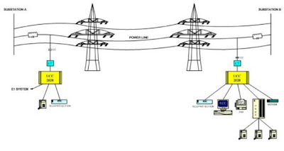

Imagen 2: Example of PLC connection  
<https://electricalbaba.com/power-line-carrier-communication-plcc/>

***Alternative 6: Use of low-orbit satellite communication technology***

* Although it is a cheaper alternative to a broadband satellite. Due to their low orbit, LEO satellites experience greater atmospheric drag, which exerts a force on them and causes them to gradually lose altitude and eventually re-enter Earth's atmosphere. This implies the need to conduct maintenance maneuvers and replace the satellites periodically to keep the constellation operational. Costs that the company would have to assume periodically.

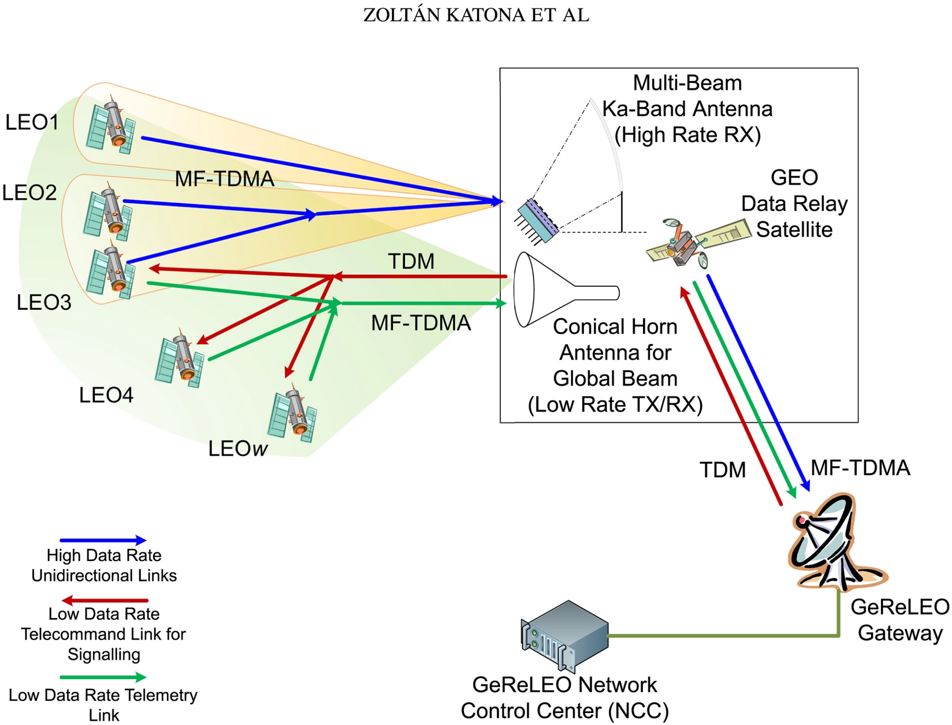

Imagen 3: Example of LEO connection  
<https://onlinelibrary.wiley.com/doi/full/10.1002/sat.1333>

**Step 5. Evaluation and Selection of the best solution.**

**Criteria**

A criteria base has been defined to evaluate which of the proposals coincides with the best solution. In this case, three different criteria have been established with which to determine the best solution.

* Criterion A:**Stability**. The stability of each option in terms of internet connection must be considered, this implies evaluating the ability to maintain a connection without interruptions, minimizing signal loss and downtime. Option stability is measured in three categories:
* **Stable:** A reliable solution, which solves one of the main problems that the company currently presents: Frequent network failure
* **Moderately Stable:** An affordable solution, which meets the main problem of the company, but which presents a limitation(s) to consider that would make the problem persist in the long term.
* **Unstable:** A solution that fails to meet the needs or that presents different limitations that can cause major problems for the company.
* Criterion B:**Cost**. The current situation of the company must be considered, due to the need to adapt the solution to the current resources of a single network antenna, it must be sought that the solution is economically achievable, therefore three categories are defined for this criterion:
* **Economic:** The proposed solution helps keep costs low for the company and is sustainable in the long term.
* **Adjusted:** The proposed solution has low costs and is viable, however, it can be presented that the resources for this solution to continue to be sustainable in the long term have highly variable costs.
* **Expensive:** The proposed solution exceeds the costs that the company has in mind, although it solves the problem, it generates inconveniences for the company due to its maintenance.
* Criterion C: **Practicality**. The solution considers the need to be applicable in the specific rural environment. This implies considering factors such as the availability of resources, the existing infrastructure of the system and geographical limitations, for this reason three categories are defined for this criterion:
* **Effective:** The proposed solution is practical, since it uses the available resources efficiently and takes advantage of the existing infrastructure in the rural environment, which makes it viable and beneficial for both the company and the community.
* **Useful:** The proposed solution is moderately practical since it is viable in the rural environment. However, there are some variations in the resources needed to keep it sustainable in the long term, which could create some additional challenges for the company in terms of planning.
* **Impractical:** The proposed solution is not practical, since it exceeds the resources established by the company. Although it solves the connectivity problem in rural areas, it generates significant inconveniences for the company, which makes it not recommended in this specific context.
* Criterion D:**Coverage**. The solution considers the capacity to provide a wide and effective coverage in the rural area, considering the extension, scope and overcoming of geographical obstacles. This criterion can be divided into three categories:
* **All risks:** The solution offers broad and effective coverage in rural areas. The signal has a considerable range, reaching remote areas without issue and overcoming significant geographic obstacles.
* **Limited:** The solution provides acceptable coverage in rural areas. The signal has a moderate range, although there may be some remote or cluttered areas where the connection is less stable.
* **Insufficient:** The solution has terrible coverage in rural areas. The signal has a reduced range, making it difficult to reach remote areas and overcome geographical obstacles. This can result in poor, intermittent or even absent connectivity in some areas of the rural locality, severely limiting internet access for users.

*Assessment*

Evaluating the above criteria in the previously proposed alternatives, we obtain the following table:

|  |  |  |  |  |  |
| --- | --- | --- | --- | --- | --- |
| **Alternative** | **Criterion A** | **Criterion B** | **Criterion C** | **Criterion D** | **Total** |
| **Implementation of long-range wireless technology (A)** | 2 | 1 | 3 | 3 | 9 |
| **Collaboration with local and community suppliers (B)** | 2 | 3 | 2 | 3 | 10 |
| **Use of mesh network technology (C)** | 3 | 2 | 3 | 3 | 11 |

**Selection**

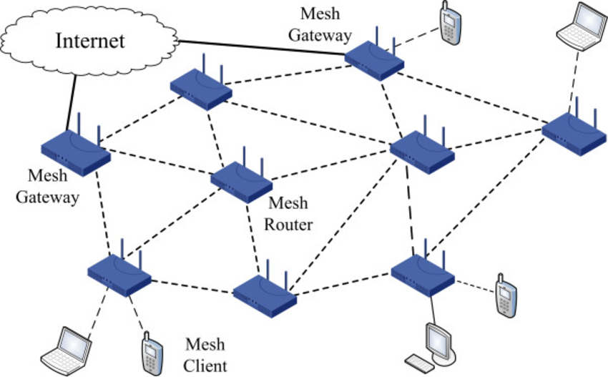

**Image 4: Example of Red Mesh**[**https://www.researchgate.net/figure/Wireless-mesh-network-architecture-with-mesh-gateway-mesh-routers-and-mesh-clients_fig2_257877841**](https://www.researchgate.net/figure/Wireless-mesh-network-architecture-with-mesh-gateway-mesh-routers-and-mesh-clients_fig2_257877841)

Based on the previous evaluation, the alternative of Using mesh network technology is the best option for this problem situation, especially highlighting its Stability, Practicality and Cost. While the other options could be considered by standing out in other ways, they lack capabilities that solution C possesses.

* Option A stands out more than others in the Practicality and Coverage criteria, when managing wireless connections, it would be possible to solve the problem satisfactorily and easily, however, in addition to geographical conditions, weather conditions would have to be considered, which influence drastically in the stability of the solution, not to mention that it is the most expensive solution to implement and maintain in the long term
* Option B stands out more than others in the Cost and Coverage criteria, by allowing the community in the area to help cover the expenses, it could be possible to collaborate to provide a better service, in addition, with the help of these same people, it is possible to have a better understanding of the area and how to organize a sustainable system, however, the practicality and stability of this joint system may decay over time as it requires capital and constant collaboration to function continuously.

1. **Specification of requirements.**

**Requirements Analysis Table.**

|  |  |
| --- | --- |
| **Client** | Communications Company |
| **User** | Network Manager |
| **Functional requirements** | **1 - Add node:** The program must allow the registration of a Mesh network node.  **2 - Modify node:** The program must allow the modification of a Mesh network node from a provided IP address.  **3 - Delete node:** The program must allow the removal of a node from the Mesh network.  **4 - Create link:** The program must allow communication links to be established between Mesh network nodes.  **5 - Modify link:** The program must allow the network manager to modify the properties of an existing link in the Mesh network.  **6 - Delete link:** The program must remove a link between nodes in the Mesh network.  7 - Dijkstra's Search: The system must allow shorter queries from one node to another for network node management reasons.  8 - Floyd Warshall’s Search: The system must allow the shortest consultation of a node with the other nodes of the network for network node management reasons.  9 - Establish load balancing rules to distribute traffic appropriately: The system must allow the allocation of a minimum of connection strength in the network to achieve the objectives that have been set.  10 - Verify the capacity of each link: The system must allow the strength of the connection to each node of the network, through bsf. |
| **Context of the problem** | In a specific rural location, an Internet connectivity service provider faces significant challenges due to the lack of coverage and stability in its network. With only a single network antenna available, residents and local businesses experience frequent connection drops, affecting their productivity, communication, and access to online services. In order to improve the quality of service, it has been decided to implement a Mesh network using networks as the technological basis. This will allow the establishment of a decentralized network infrastructure and optimize communication between nodes to provide a more reliable and stable connection to the rural community. |
| **Non-functional requirements** | **1 -** The program must manage the exceptions that may be generated when searching for a node or link, when the signal stretch doesn't satisfy the rules to distribute traffic appropriately.  **2 -** Generate alerts or notifications in the event of connection failures or degradations. |
| **Product requirements** | **1 -** Must have at least ten commits within 1 hour of each other.  **2 -** The design of data structures should be designed using the ADT. |

**Functional Requirements Analysis Tables.**

|  |  |  |  |
| --- | --- | --- | --- |
| **Name or identifier** | **1 - Add node** | | |
| **Summary** | Add a node to the mesh network | | |
| **Inputs** | Input name | Datatype | Selection or repetition condition |
| ipAddress | String | Can't be empty |
| bandwidth | double | Can't be null, or below zero |
| name | String | Can't be empty |
| **General activities necessary to obtain the results** | The system will validate the information and create the new node. | | |
| **Result or post-condition** | Returns a successful message. | | |
| **Outputs** | Output name | Datatype | Selection or repetition condition |
| msg | String | - |

|  |  |  |  |
| --- | --- | --- | --- |
| **Name or identifier** | **2 - Modify node** | | |
| **Summary** | Checks that the node exists and allows modification of the node. | | |
| **Inputs** | Input name | Datatype | Selection or repetition condition |
| ipAddress | String | Must be different of null |
| newBandWith | double | Can’t be below zero |
| **General activities necessary to obtain the results** | It will search in the system data the node info that has an equal IP address based on the provided IP address. | | |
| **Result or post-condition** | The modify node with the added information | | |
| **Outputs** | Output name | Datatype | Selection or repetition condition |
| Node | node | Must be the only one with the same IP address |
| msg | String | Change according to the status |

|  |  |  |  |
| --- | --- | --- | --- |
| **Name or identifier** | **3 - Delete node** | | |
| **Summary** | Checks that the node exists and allows delete of the node. | | |
| **Inputs** | Input name | Datatype | Selection or repetition condition |
| ipAddress | String | Must be different of null |
| **General activities necessary to obtain the results** | It will search in the system data the node info that has an equal IP address based on the provided IP address. Eliminate the node and the connections between the other nodes | | |
| **Result or post-condition** | A message that notify the successful delete operation | | |
| **Outputs** | Output name | Datatype | Selection or repetition condition |
| msg | String | Change according to the status |

|  |  |  |  |
| --- | --- | --- | --- |
| **Name or identifier** | **4 - Create link** | | |
| **Summary** | The program must allow communication links to be established between Mesh network nodes, allowing to define the quality of each link (e.g., signal strength or bandwidth) to optimize network performance. | | |
| **Inputs** | Input name | Datatype | Selection or  repetition condition |
| initialNodeIP | String | Node IP must be different than null |
| finalNodeIP | String | Node IP must be different than null |
| signalStrenght | Double | Quality must be not negative |
| **General activities necessary to obtain the results** | The link must have a valid Start Node, End Node, and specify the desired link quality. | | |
| **Result or post-condition** | A new link between Initial and Final Node has been created | | |
| **Outputs** | Output name | Datatype | Selection or repetition condition |
| msg | String | - Link has been created  - Link already exists |
| LinkId | String | - LinkId must be unique |

|  |  |  |  |
| --- | --- | --- | --- |
| **Name or identifier** | **5 - Modify link** | | |
| **Summary** | The program must allow the network manager to modify the properties of an existing link in the Mesh network. | | |
| **Inputs** | Input name | Datatype | Selection or  repetition condition |
| option | Integer | Option must be one of the modifiable variables (quality) |
| linkID | String | It must be different than null |
| **General activities necessary to obtain the results** | The existence of the connection is checked and its information is changed. | | |
| **Result or post-condition** | The modification of the link has been successfully performed. | | |
| **Outputs** | Output name | Datatype | Selection or repetition condition |
| msg | String | - Link has been modified  - Link doesn’t exist |

|  |  |  |  |
| --- | --- | --- | --- |
| **Name or identifier** | **6 - Delete link** | | |
| **Summary** | The program must remove a link between nodes in the Mesh network | | |
| **Inputs** | Input name | Datatype | Selection or  repetition condition |
| option | Integer | Option must be one of the modifiable variables (quality) |
| linkID | String | Link id must exist |
| **General activities necessary to obtain the results** | The existence of the connection is checked, the node and his links are deleted. | | |
| **Result or post-condition** | The Link has been successfully removed. | | |
| **Outputs** | Output name | Datatype | Selection or repetition condition |
| msg | String | - Link has been delete  - Link doesn’t exist |

|  |  |  |  |
| --- | --- | --- | --- |
| **Name or identifier** | **7 - Dijkstra's Search** | | |
| **Summary** | Find the shortest routes between the nodes of the network | | |
| **Inputs** | Input name | Datatype | Selection or  repetition condition |
| initialNodeIP | String | Must be different of null |
| **General activities necessary to obtain the results** | Find the adjacent nodes and update accumulated distances. A priority queue is used to efficiently select the next node to scan, prioritizing the one with the lowest accumulated distance. | | |
| **Result or post-condition** | Array containing the cumulative distances from the initial node to all other nodes in the network | | |
| **Outputs** | Output name | Datatype | Selection or repetition condition |
| dijkstra | String[] | Changes according to the cycles |

|  |  |  |  |
| --- | --- | --- | --- |
| **Name or identifier** | **8 - Floyd Warshall’s Search** | | |
| **Summary** | Find the minimum distances between pairs of nodes of a network | | |
| **Inputs** | Input name | Datatype | Selection or  repetition condition |
| initialNodeIP | Node | Must be different of null |
| finalNodeIP | Node | Must be different of null |
| middleNodes | int | Must be higher or equal than zero |
| **General activities necessary to obtain the results** | Iterate over all pairs of nodes and consider an intermediate node at each iteration. The minimum distances between nodes are updated if a shorter path is found through the intermediate node.  The minimum distances between nodes are updated if a shorter path is found through the intermediate node. | | |
| **Result or post-condition** | Distance Matrix containing the minimum distances between all pairs of nodes in the network | | |
| **Outputs** | Output name | Datatype | Selection or repetition condition |
| warshall | Int [][] | Changes according to the cycles and middle nodes |

|  |  |  |  |
| --- | --- | --- | --- |
| **Name or identifier** | **9 - Establish load balancing rules to distribute traffic appropriately** | | |
| **Summary** | Allows to set the minimum bandwidth in the traffic for notifications. | | |
| **Inputs** | Input name | Datatype | Selection or  repetition condition |
| minimumBandWith | double | Can’t be below zero |
| **General activities necessary to obtain the results** | The value is checked for validity and will be the minimum bandwidth value in the network. | | |
| **Result or post-condition** | A message notifies the successful operation. | | |
| **Outputs** | Output name | Datatype | Selection or repetition condition |
| msg | String | Change according to the status |

|  |  |  |  |
| --- | --- | --- | --- |
| **Name or identifier** | **10 - Verify the capacity of each link** | | |
| **Summary** | Allows to display the bandwidth of a node with the other nodes in the network. | | |
| **Inputs** | Input name | Datatype | Selection or  repetition condition |
| ipAddress | String | Must be different of null |
| **General activities necessary to obtain the results** | The node is checked for existence, its bandwidth is calculated and displayed with the other nodes in the network. | | |
| **Result or post-condition** | A list of the node's bandwidth with all the other nodes | | |
| **Outputs** | Output name | Datatype | Selection or repetition condition |
| list | String | Change according to the status |